Diabetes in Pregnancy Register
Information for participation in a national register and research

Dear Reader,

With this information letter we would like to ask you if you are interested in participating in a Dutch national register. Participation is voluntary. You receive this letter because you have diabetes and are pregnant.

Whether or not you participate has no consequences for the treatment you receive.

Here you can read what kind of register it is, what it means for you and what is expected of you when you decide to participate.

Are you interested?
- Read this letter carefully.
- Ask questions to the researcher who gave you this information.
- Talk to your partner, family or friends about participating in this register.

Would you like to participate? Then fill in the form in the attachment.

- General information
The register was set up by Amsterdam UMC and is carried out by healthcare providers in various hospitals in the Netherlands.

- What is the purpose of the register?
The aim of this national register is to improve the health and quality of life of pregnant people with diabetes and their children. Diabetes brings many challenges, especially during pregnancy. We are investigating the use of various diabetes treatments during pregnancy. For example, we are looking to answer the following questions: what impact does diabetes technology (like insulin pumps or glucose sensors) have on blood glucose regulation during pregnancy? And how does it affect pregnancy outcomes? Diabetes treatment keeps changing. That’s why it’s important to store the register data for a long time. This helps us learn more about how different diabetes treatments during pregnancy affects both mother and the child(ren).

- What happens if you participate in the register?
If you choose to participate in the register, we will collect all relevant information about the effect of your diabetes treatment during your pregnancy on pregnancy outcomes. Table 1 shows what information we collect and how we plan on collecting it.

How? | What data?
Directly from you | - Personal data: your date of birth, address, email address, telephone number  - Background information: Your ethnicity, education level, income, employment, marital status  - Voluntary questionnaires: Your experiences with care, your quality of life and your experience with your own diabetes treatment
Your medical file  (Hospital(s) where you are known, your GP) | - Medical history  - Treatments and hospitalizations (e.g., diabetes treatment)  - Pregnancy and childbirth data (e.g., birth weight, complications)  - Date of birth and sex of your child(ren)*
Other Dutch registers* | - Health and medical data  - Pregnancy and childbirth information  - Lifestyle and socio-economic factors  - Diabetes data
Table 1. The information we collect.*Only if you give consent (see Section 6).

The Data Collection Flowchart on the next page provides an overview of how we collect data for the register.
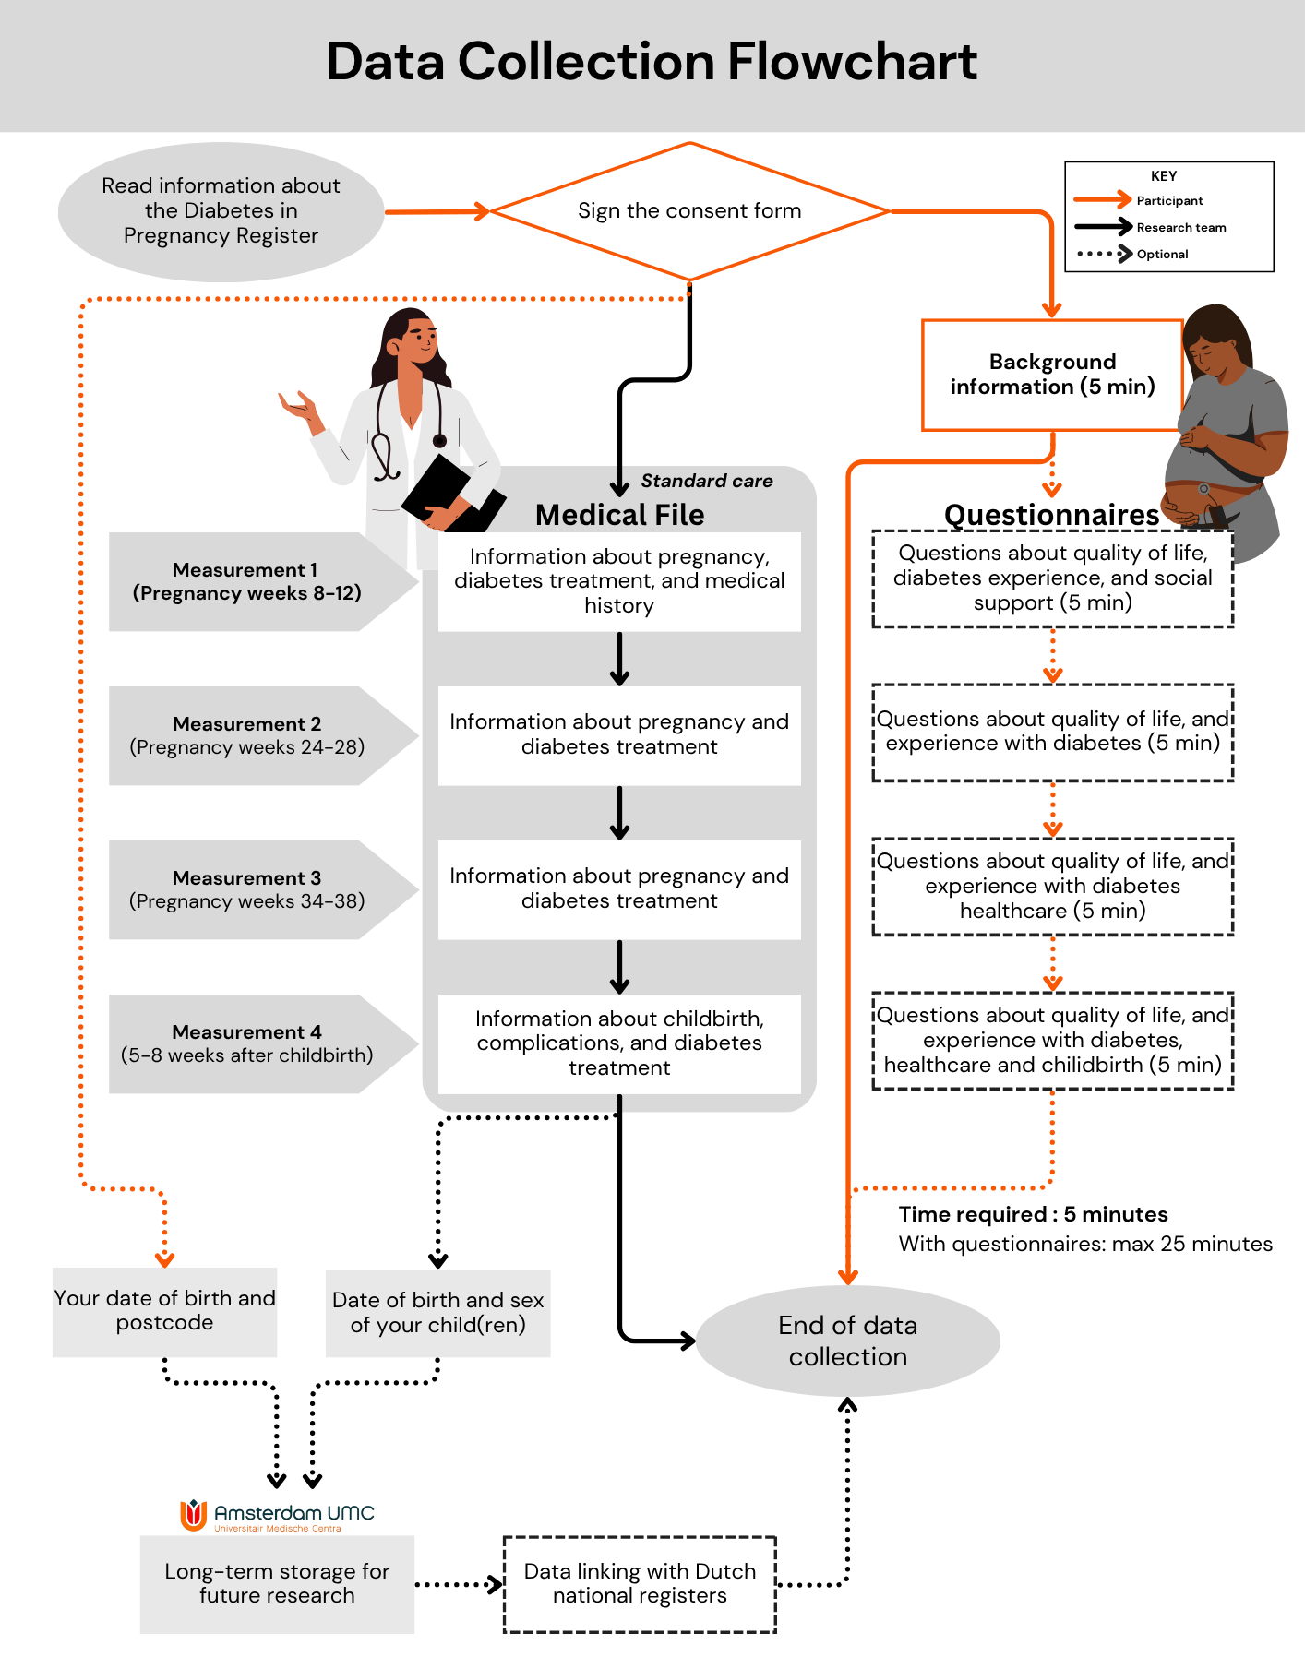

Most of this data comes from your medical records, collected during your appointments with the internist or diabetes nurse during your pregnancy. This will not cost you any extra time. In addition, we ask you to fill in some information about yourself in an online survey. Participation is not possible without this background information. For the question about ethnicity, we ask you to indicate which ethnic group you identify yourself with.

Questionnaires
We will ask you to complete a short questionnaire four times as part of the register, at the same times as the data collection (See 'Data Collection Flowchart'). These will give us more information about your experiences around pregnancy and diabetes. Completion of the questionnaires is completely voluntary. If you choose to complete them, you can fill them in when it suits you around the indicated measurement period.

- What does participation mean to you?
You will not directly benefit from participating in this register. Your participation can help us learn more about the treatment of diabetes during pregnancy in the Netherlands. Please note that participation does require a little time investment from you. You can the estimated time investment in the Data Collection Flowchart (page 3).

- If you do not want to participate or wish to stop participating.
Participation in the register is entirely voluntary. You can withdraw your consent at any time and you don't have to say why you no longer wish to participate. However, you must report this wish to the research team in your hospital (Appendix 1). However, your data that has was already collected before you withdraw can still be used in a scientific study.

- What do we do with your data?
Why do we collect, use and store your data?
We collect, use and store your data to answer the research questions. If researchers use your data for their scientific research, they will publish the results of that research.

How do we protect your privacy?
To protect your privacy, we assign a unique code to your data. This code is used for all your data. We store the key to the code in a secure place in the [HOSPITAL NAME]. Only the investigator and members of the research team at the [HOSPITAL NAME] will know which code belongs to you. When we process or share your data, we only use that code. In reports and publications about the register, no one will know that it was about you.

How long do we keep your data?
We will store your data for at least 15 years in the [HOSPITAL NAME]and Amsterdam UMC. After that, we will check every 5 years whether it is still necessary to keep the data longer.

Can we link your data to existing registrations?
We believe it’s very important to understand the long-term impact of diabetes during pregnancy, both on mothers and their child(ren). To study these long-term effects we need to request your and your child(ren)s data from other organizations. These organizations already collect health information about individuals. Think of the general practitioner, the pharmacy, other hospitals and Dutch national registers such as RIVM or CBS. We would then link the relevant data from our register to the data obtained from those organizations. To facilitate this data linking, we need a date of birth, address, and sex. We ask you for separate consent for this. If you do not give consent, you can still participate in the register. All personal data collected for linking, is stored securely at [HOSPITAL NAME] and Amsterdam UMC. Personal data is kept separate from the research data with a code. The key to the code is stored securely in the [HOSPITAL NAME] and Amsterdam UMC. We will only request data from approved and audited registries that meet privacy and security standards (Table 2).

Sources | Short description | Examples of data
General Practices (NL: “Huisartsen”), Pharmacies, Other Hospitals | Access to medical data is important for general information about health status, conditions and complications. | - Diagnoses and medical history  - Medication use  - Treatments and hospitalizations
Statistics Netherlands (Centraal Bureau voor de Statistiek; CBS) | Records health data such as information on diseases, healthcare use, life expectancy, lifestyle and causes of death of the population. | - Health survey  - Lifestyle  - Socioeconomic factors  - Mortality data
Child and Youth Health Care (Jeugdgezondheidszorg; JGZ) | Contains data on the growth, development and health of children in the Netherlands aged 0 to 18 years, including vaccinations and screenings programs. | - Health data  - Lifestyle  - National Immunization Program
National Institute for Public Health and the Environment (Rijksinstituut voor Volksgezondheid en Milieu; RIVM) | Collects data on public health, the environment and disease prevention. | - Health data  - Lifestyle and socio-economic factors  - Population screenings  - National Immunization Program
Dutch Perinatal Registration (Perined) | Contains information about pregnancy outcomes and complications. | - Childbirth data  - Complications of mother during pregnancy and childbirth  - Complications of the child after childbirth
Dutch Pediatric and Adult Registration of Diabetes (DPARD) | Provides access to anonymized hospital data of known diabetes patients. | - Diabetes complications
PHARMO Data Network – DIAMANT Cohort | Provides access to diabetes data from primary care. | - Long-term management of diabetes  - Treatment patterns
Table 2. Examples of recognized Dutch national registries and other medical organizations from which we may request data. In the future, other approved registrations can be added which do not exist yet.

Can we send your data outside the European Economic Area (EEA)?
After data collection, we may want to send your coded data to countries outside the European Union. The privacy rules of the European Union do not apply in those countries. But your privacy will be protected on an equal level. The purpose of this is to be able to combine data from comparable, international studies. We will ask you separately for permission to transmit your coded data on the consent form. If you decide that you do not want us to send your coded data outside of EEA, you can still participate in the study.

Can we use your data for a follow-up investigation?
After the register, we may conduct another study in the field of diabetes and pregnancy. We’re interested to know if it’s okay for us to contact you about a future study. On the consent form, you can say whether you give consent for this.

Want to know more about your privacy?
Would you like to know more about your rights regarding the processing of personal data? You can find more information here:
https://www.autoriteitpersoonsgegevens.nl/en/themes/basic-gdpr/privacy-and-personal-data
Do you have questions about your rights? If so, please contact the Data Protection Officer responsible for the processing of your personal data (Appendix 1). If you have any complaints about your privacy, we encourage you to first discuss them with the research team (Appendix 1).

Where can you find more information about the study?
You can find more information about the study on the following website: www.diapreg.nl

- Do you have any questions?
This register has been assessed by the non-WMO review committee of the Amsterdam UMC. Setting up this register does not fall under the Medical Research Involving Human Subjects Act (WMO). If you have any questions about this register, please contact the Amsterdam UMC research team or the treatment team that cares for women with diabetes who are pregnant in your hospital.

Thank you for your time.
Appendix 1. Contact details
General information about the register and your privacy can be found on our website:
www.diapreg.nl
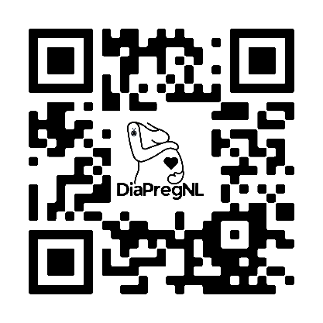

You can get more information about the register from your doctor or one of the researchers at Amsterdam UMC:
Principal Investigator: Dr. S. E. Siegelaar, internist-endocrinologist, Department of Endocrinology and Metabolism, Amsterdam UMC
Coordinating researcher: Drs. V. Duwel, physician-researcher, Department of Endocrinology and Metabolism, Amsterdam UMC

You can reach us by email: diapreg-register@amsterdamumc.nl or by phone: 020-5666071.

Data Protection Officer:
[FG contact details per hospital]

Appendix 2: Participant consent form
Diabetes in Pregnancy Register
- I fully read the information letter. I was also able to ask questions. My questions were answered sufficiently. I had enough time to decide whether I want to participate.
- I know that participating is voluntary. I also know that I can decide at any time to not participate or to withdraw from the register. I know that I don't have to give a reason for it.
- I consent to the collection and use of my data, including ethnicity, and data of my newborn child(ren) in the manner and for the purposes stated in the information letter.
- I give permission to the members of the research team to view and use the required data for this register from my medical file and that of my newborn child(ren).
- I consent to be approached by researchers to participate in questionnaires about my experiences with care, quality of life and experience with diabetes during this pregnancy.
- I consent to the transfer of my data and data of my newborn child(ren) within the framework of this register to countries within the EEA where the European directives for the protection of personal data apply (GDPR). The data transferred must be coded, and without my name.
- I give permission to keep my data and data of my newborn child(ren) for at least 15 years after this register within Amsterdam UMC, location AMC. After that, they are stored for as long as necessary, provided that the storage is evaluated every 5 years and that the purpose storage is significant.

Please check “Yes“ or “No“ in the boxes below:

I agree with the above and want to participate in this register. | ☐Yes | ☐No

If you tick 'No' below, you can still participate in this survey:
I consent to link my personal data and personal data of my newborn child(ren) to existing Dutch registries and data sources for this study, as mentioned in the information letter (Table 2), and to store them in the [HOSPITAL NAME] and Amsterdam UMC (location AMC), as long as this data is treated confidentially and is only used for this register. | ☐Yes | ☐No
I consent to the use of my coded data and that of my child(ren) outside the EEA for the purpose of merging data with other studies. | ☐Yes | ☐No
I give DiaPregNL research team permission to approach me for another study in the field of diabetes and pregnancy. | ☐Yes | ☐No

Participant Name : ……………………………………………………………………………………………….
Place and date : ………………………………………………………………………………………………

Signature : ………………………………………………………………………………………………

Please fill in your personal data on the next page.
I declare that I have fully informed this participant about the register. If information becomes known during the study that could influence the participant's consent, I will inform him/her in a timely manner.

Name of investigator : …………………………………………………………..
Date : ……………………………………………………………

Investigator's signature : ……………………………………………………………
--------------------------------------------------------------------------------------------------------------------------------------
Participant’s personal data

Date of birth
  D | D |  | M | M |  | Y | Y | Y | Y
Phone number | ……………………………………………………………………………………………
Email address | ……………………………………………………………………………………………
Street name and house number | ……………………………………………………………………………………………
Postal code
City | ……………………………………………………………………………………………
Country | ……………………………………………………………………………………………

--------------------------------------------------------------------------------------------------------------------------------------
The participant should receive a complete information letter, together with a copy of the signed consent form.

